The Evidence of Sufficient Philosophy from Greek to Recent Concept

By
Kanokphan Sirithienthong | 6610750092
Phurin Meechanchuang | 6610754250
Monprach Pattamakeansai | 6610750459
Athipat Suriam | 6610750629
Nathorn Apichaikriengkrai | 6610750190
Rapeerat Chen | 6610750483

Section 415
Submitted to:
Assoc.Prof. Kanokwan Chancharoenchai, Ph.D

History of Economic Thought
Bachelor of Economics (English Program)
Kasetsart University

First Semester, Academic Year 2025

Abstract
This report traces the ethical roots of economic thought from classical Greece to Thailand’s Sufficiency Economy Philosophy (SEP). Beginning with Xenophon’s view of economics as household stewardship, it explores how Socrates, Plato, and Aristotle shaped ideas of moderation, structured harmony, and moral balance. These principles reemerge in SEP—introduced by His Majesty King Bhumibol Adulyadej—as a framework for sustainable development grounded in moderation, reasonableness, and self-immunity. Through philosophical analysis and Thai case studies, the report affirms sufficiency as a timeless ethic of resilience and wellbeing.
Introduction
Before economics became a science of markets, equations, and efficiency, it was a branch of philosophy—a way of thinking about how to live well. In ancient Greece, thinkers like Xenophon, Socrates, Plato, and Aristotle laid the ethical foundations of economic life, not through models or data, but through questions of virtue, justice, and balance. Their inquiries were not about maximizing wealth, but about cultivating character, managing resources wisely, and building harmonious communities.
Among them, Xenophon’s Oeconomicus stands out as one of the earliest texts to define economics as the art of household management. In his view, a well-run household was not measured by its riches, but by its discipline, foresight, and moral integrity. This early framing of economics as stewardship—rooted in ethics rather than accumulation—would echo through the centuries.
Fast forward to modern Thailand, and we find a striking resonance in the Sufficiency Economy Philosophy (SEP), introduced by His Majesty King Bhumibol Adulyadej. SEP emerged as a response to the pressures of globalization and economic crisis, offering a framework grounded in moderation, reasonableness, and self-immunity. Like the Greek philosophers, SEP emphasizes that true prosperity begins with ethical living, prudent governance, and resilience from within.
Xenophon and the Origin of Economics
Long before economics became a formal discipline, Xenophon (c. 430–354 BCE) offered one of its earliest conceptual foundations. A student of Socrates, Xenophon was not only a philosopher but also a soldier, historian, and practical leader. His work Oeconomicus presents economics not as market theory, but as the art of managing a household—a concept rooted in ethics, foresight, and stewardship.
In Oeconomicus, Xenophon defines economics as the skill of running a household well (oikos), emphasizing that success depends not on wealth alone, but on discipline, prudence, and moral character. Through a Socratic dialogue, he portrays the head of the household as a steward—not just of property, but of wellbeing. This early framing of economics as ethical management laid the groundwork for later philosophical and economic thought.
To appreciate how far the definition of economics has evolved, consider this contrast:
“Economics is the art of managing the household well.” — Xenophon, Oeconomicus (c. 4th century BCE)
“Economics is the science which studies human behavior as a relationship between ends and scarce means which have alternative uses.” — Lionel Robbins, An Essay on the Nature and Significance of Economic Science (1932)
Xenophon’s view centers on purposeful living, while Robbins’ modern definition focuses on scarcity and choice. One is grounded in ethics and sufficiency; the other in rational allocation. Yet both reflect a shared concern: how humans navigate limited resources.
Xenophon’s Oeconomicus is often cited as a proto-economic text—not part of formal theory, but foundational in shaping economic values. His emphasis on moderation, self-reliance, and ethical leadership resonates strongly with Thailand’s Sufficiency Economy Philosophy (SEP). Both begin at home—with how we live, how we care, and how we define “enough.”

From Greek Moderation to Ethical Economy
While Xenophon introduced economics as household stewardship, it was Socrates, Plato, and Aristotle who deepened its ethical foundations. These thinkers didn’t write economic treatises, but their philosophies shaped enduring values—moderation, justice, and balance—that continue to guide economic life.
Socrates: Ethics Begins with the Self
Socrates (c. 470–399 BCE) believed that wisdom begins with self-examination. Through his method of questioning—known as the Socratic dialogue—he challenged others to uncover contradictions and clarify their values. In Gorgias, he warns against rhetoric divorced from truth, arguing that persuasion must serve justice. This resonates with SEP’s principle of reasonableness, which calls for ethical decision-making rooted in truth and integrity.
In Oeconomicus, Socrates discusses household management not as a technical skill, but as ethical stewardship. A well-run household requires discipline, foresight, and virtue—not just wealth. This mirrors SEP’s emphasis on moderation, encouraging individuals and institutions to live within their means and prioritize sustainability.
Socrates lived simply and died for his principles. His life reminds us that sufficiency begins with the self, and that true prosperity is measured not by accumulation, but by character.
Plato: Justice Through Structured Harmony
Plato expanded Socratic ethics into a full political philosophy. In The Republic, he envisioned the Ideal City (Kallipolis), where justice arises when each class performs its proper role. The city reflects the tripartite soul—reason, spirit, and appetite—mapped onto Guardians, Auxiliaries, and Producers (see Table 1).
Plato’s structure is illustrated in Figure 1, showing how education, property, and governance are distributed to preserve harmony. Guardians live communally and govern through wisdom; Auxiliaries defend with honor; Producers sustain the city through temperance and labor. The Noble Lie reinforces unity by symbolically assigning metals to each class—gold, silver, and bronze.
Figure 1: Structure of the Ideal City
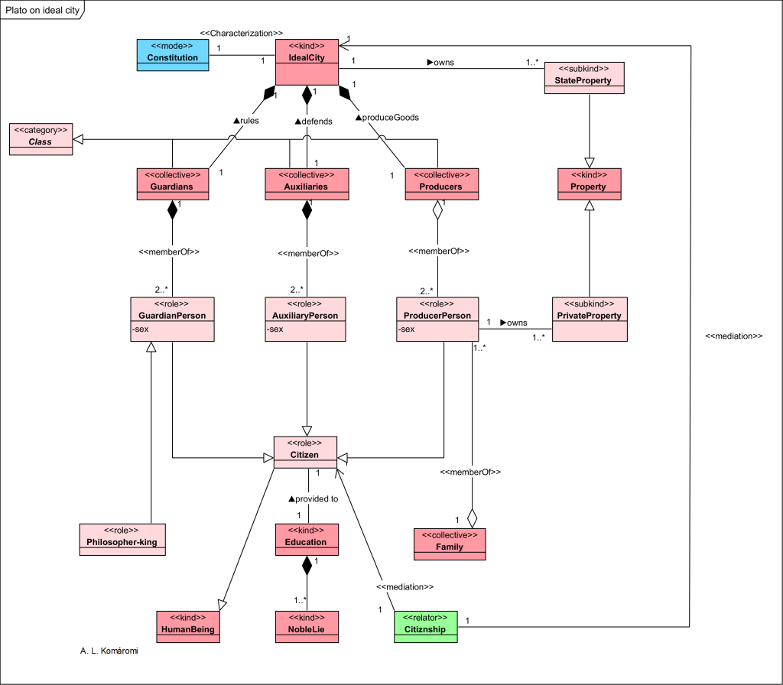

Table 1: Plato’s Tripartite Soul and Class Structure in the Ideal City
Part of the human soul | Psychological constitution | Virtue | Class of the City
Reason | Aristocratic | Wisdom | Guardians
Spirit | Timocratic | Honor | Auxiliaries
Appetite | Oligarchic  Democratic  Tyrannical | Temperance | Producers
Though Plato didn’t write explicitly on economics, his vision of communal living and property restrictions reflects a normative stance on wealth distribution and ethical governance. These ideas prefigure debates on economic justice and institutional design, and align with SEP’s call for structured roles, moral development, and collective resilience.
Table 2: Structural Components of Plato’s Ideal City (Kallipolis)
Class | Description | Relations
IdealCity | The Ideal City (Kallipolis) includes three classes: Guardians, Auxiliaries, and Producers. | —
Class | A collection of Citizens with shared tasks and traits. | Generalizes Guardians, Auxiliaries, Producers
Constitution | The laws and rules governing the city. | Characterizes IdealCity
Guardians | Ruling class using propaganda, censorship, and philosophical training. | Subkind of Class; exclusive to IdealCity
Auxiliaries | Military class enforcing laws and defending the city. | Subkind of Class; exclusive to IdealCity
Producers | Working class responsible for goods and services. | Subkind of Class; exclusive to IdealCity
Citizen | A human being with legal status. | Role of HumanBeing
GuardianPerson | A philosophically trained citizen; lives communally without private family. | Subkind of Citizen; member of Guardians
Philosopher-king | A GuardianPerson educated in philosophy, governance, and leadership. | Subkind of GuardianPerson
AuxiliaryPerson | A citizen-soldier in the class of Auxiliaries. | Subkind of Citizen; member of Auxiliaries
ProducerPerson | A citizen-worker in the class of Producers may have a private family. | Subkind of Citizen; member of Producers and Family
Education | Class-specific training: philosophical for Guardians, military for Auxiliaries, and primary for Producers. | Provided to Citizen
NobleLie | A myth promoting class acceptance: gold for Guardians, silver for Auxiliaries, bronze for Producers. | Part of Education
Family | Private families permitted only for Producers. | —
Property | Includes land, assets, and materials. | —
PrivateProperty | Allowed only for Producers. | Subkind of Property; owned by ProducerPerson
StateProperty | Controlled by Guardians on behalf of the state. | Subkind of Property; owned by the State
HumanBeing | A person with biological and social identity. | —
Citizenship | Legal status connecting a human being to the state. | Relates Citizen with State
Aristotle: Balance as the Foundation of Virtue
Aristotle, Plato’s student, took a more empirical approach. In his ethics, virtue lies in the Golden Mean—the balance between excess and deficiency. Courage, for example, is the mean between cowardice and recklessness. This concept is visualized in Figure 2, mapping traits like integrity, love, and discernment as balanced virtues.
Figure 2: Aristotle’s Golden Mean – Ethical Balance Between Extremes
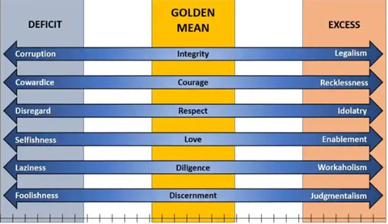
Aristotle believed that ethics must be cultivated through habit and reason, and that economics is part of this ethical life. He saw the household (oikos) and community (polis) as spaces for practicing moderation, preparing for uncertainty, and living well.
This aligns with SEP’s principle of self-immunity—the ability to withstand external shocks through prudent living. Like Aristotle, SEP rejects excess and encourages thoughtful preparation, ethical conduct, and long-term wellbeing.
Together, these Greek thinkers laid the foundation for an ethical economy—one that values restraint, responsibility, and resilience. Their ideas echo across centuries, showing that sufficiency isn’t just a Thai concept—it’s a timeless philosophy of how to live wisely and govern well.
Linking Xenophon to Thailand’s Sufficiency Economy Philosophy (SEP)

His Majesty King Bhumibol Adulyadej
Thai SEP: Philosophy Rooted in Resilience
The Sufficiency Economy Philosophy (SEP) was introduced by His Majesty King Bhumibol Adulyadej as a guiding framework for Thailand’s sustainable development. In Thai, it is known as ปรัชญาของเศรษฐกิจพอเพียง, emphasizing ความพอประมาณ (moderation), ความมีเหตุผล (reasonableness), and การมีภูมิคุ้มกันในตัวที่ดี (self-immunity). SEP is not a technical model—it is a moral compass for decision-making, applicable to individuals, communities, and institutions.
SEP gained national prominence during the 1997 Asian financial crisis, when Thailand faced economic instability. His Majesty proposed SEP as a counter-model to rapid globalization—one that prioritized resilience, local wisdom, and ethical governance. Rather than focusing on growth alone, SEP encourages individuals and institutions to live within their means, prepare for uncertainty, and act with moral clarity. Citizens often describe SEP as a “way of life.” Farmers speak of growing what they need and sharing with neighbors. Entrepreneurs avoid over-leverage and reinvest locally. Educators teach students not just how to succeed, but how to live wisely. This holistic structure is captured in Figure 3: SEP for Sustainability, which shows how knowledge and virtue support the three principles, guiding balanced progress across economic, environmental, social, and cultural dimensions.

Figure 3: SEP for Sustainability
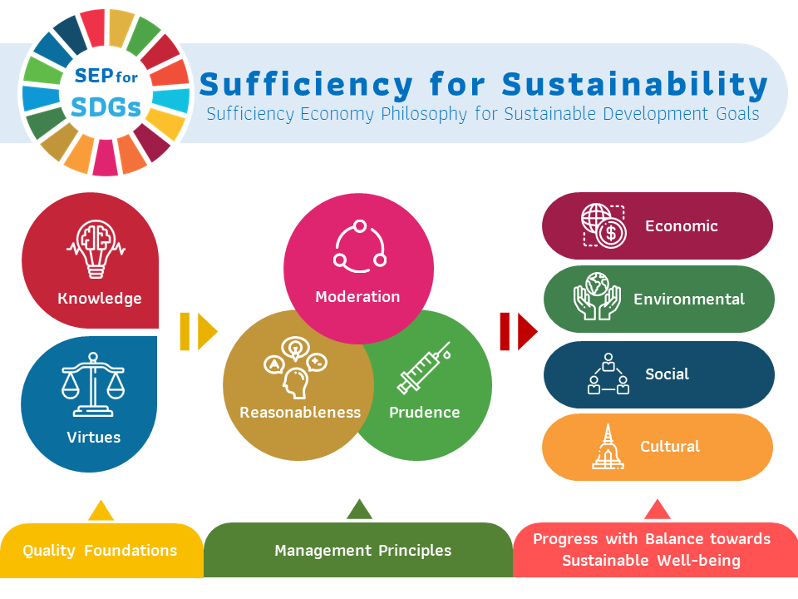
Xenophon: Ancient Foundations of Ethical Stewardship
Though separated by centuries, Xenophon’s Oeconomicus offers a surprisingly modern view of economics as ethical household management. He presents the household (oikos) not as a site of consumption, but as a unit of discipline, foresight, and moral responsibility. A good household lives within its means, prepares for uncertainty, and cultivates virtue—principles that align directly with SEP.
Xenophon’s emphasis on moderation and self-sufficiency mirrors SEP’s rejection of excess and dependence. His belief that economic success must be rooted in ethical leadership parallels SEP’s call for responsible governance. Just as SEP encourages Thai citizens to build resilience from the ground up, Xenophon saw the household as the foundation of a stable society.
The ethical economy envisioned by Socrates, Plato, and Aristotle provides philosophical depth to SEP’s principles:
- Socrates taught that wealth without virtue is meaningless. His focus on self-knowledge and moderation aligns with SEP’s call for ethical restraint and personal responsibility.
- Plato’s Ideal City, structured around reason, honor, and temperance, reflects SEP’s emphasis on structured roles and moral development. His belief in wise leadership and communal balance echoes SEP’s vision for sustainable governance.
- Aristotle’s Golden Mean, illustrated in Figure 2, shows that virtue lies between extremes. This concept of ethical balance is central to SEP’s principle of self-immunity—preparing for shocks by living wisely and avoiding both deficiency and excess.
Together, these thinkers offer a timeless foundation for SEP, showing that sufficiency is not a limitation—it is a philosophy of living well, governing wisely, and thriving sustainably.
Philosophical Continuity and Thai Cultural Integration
Thailand’s Sufficiency Economy Philosophy (SEP) is more than a development model—it is a reflection of Thai cultural values, Buddhist ethics, and centuries of lived wisdom. While SEP draws conceptual strength from classical Greek philosophy, its soul is distinctly Thai.
At its core, SEP resonates with the Buddhist principle of the Middle Way (มัชฌิมาปฏิปทา), which advocates for balance between indulgence and denial. This mirrors Aristotle’s Golden Mean, where virtue lies between extremes. Both traditions emphasize ethical restraint, self-awareness, and sustainable living—not as sacrifice, but as liberation from excess.
Thai society has long valued community interdependence, respect for nature, and spiritual mindfulness. These values are embedded in SEP’s call for:
- พอประมาณ (moderation)
- มีเหตุผล (reasonableness)
- มีภูมิคุ้มกันในตัวที่ดี (self-immunity)
The philosophy encourages individuals to act with ปัญญา (wisdom) and คุณธรรม (virtue), aligning personal choices with collective wellbeing.
This cultural integration is not theoretical—it’s visible in how SEP is practiced:
- Farmers in Chiang Mai diversify crops to reduce risk and improve food security.
- A community school in Nakhon Pathom teaches SEP through budgeting, resource planning, and ethical leadership.
- Small enterprises in Ubon Ratchathani avoid over-leverage, reinvest locally, and prioritize long-term relationships.
These examples show that SEP is not just a philosophy—it’s a practical framework for resilience across agriculture, education, and entrepreneurship.
The continuity between Greek thought and Thai SEP lies in their shared belief that economy is inseparable from ethics. Whether through Socratic introspection, Platonic structure, Aristotelian balance, or Buddhist mindfulness, the message is clear: A good society begins with good character, and sustainable development begins with sufficiency.
Conclusion
Thailand’s Sufficiency Economy Philosophy (SEP) is more than a national development model—it is a living philosophy rooted in ethical clarity, cultural wisdom, and practical resilience. By tracing its conceptual lineage through the teachings of Xenophon, Socrates, Plato, and Aristotle, this report reveals a shared foundation: that economy must serve ethics, and that prosperity must be grounded in virtue.
Socrates taught that moderation begins with the self. Plato envisioned a just society built on structured harmony. Aristotle showed that balance is the essence of moral strength. Xenophon framed economics as stewardship, not accumulation. These classical insights find renewed relevance in SEP’s principles of moderation, reasonableness, and self-immunity, adapted to Thai values and Buddhist ethics.
SEP is not static—it evolves through practice. It is taught in classrooms, lived in communities, and reflected in governance. From diversified farming in Chiang Mai to ethical entrepreneurship in Ubon Ratchathani, SEP demonstrates how philosophy becomes policy, and how ethics become action.
The ethical foundations laid by Greek philosophers did not vanish—they evolved. During the Scholastic period, thinkers like Thomas Aquinas merged Aristotelian ethics with Christian doctrine, emphasizing just price, moral trade, and the role of conscience in economic life. Later, Mercantilist thinkers formalized state-centered economic policy, focusing on national wealth, trade balances, and governance. SEP reflects a return to these ethical roots—rejecting unchecked growth in favor of balance, stewardship, and moral clarity.
In bridging ancient philosophy with Thai cultural integration, this report affirms that sufficiency is not a retreat—it is a forward-looking ethic. It invites us to reimagine prosperity not as excess, but as balance. And in that balance, we find sustainability, dignity, and shared wellbeing.

Reference
Wikimedia Commons. (2025, August 31). Xenophon, Oeconomicus (Latin) [Image]. Retrieved October 12, 2025, from https://commons.wikimedia.org/wiki/File:Xenophon,Oeconomicus%28Latin%29.jpg
Komáromi, A. L. (2019, January 15). Plato about the Ideal City in the Republic – Philosophy Models. Philosophy Models. Retrieved October 12, 2025, from https://philosophy-models.blog/2019/01/15/plato-about-the-ideal-city-in-the-republic/
Junior Officer. (2025, April 22). In All Things, Moderation: A Philosophy for Leaders. U.S. Army. Retrieved October 12, 2025, from https://juniorofficer.army.mil/in-all-things-moderation-a-philosophy-for-leaders/
Royal Thai Embassy Prague. (2021, July 7). Sufficiency Economy Philosophy (SEP). Retrieved October 12, 2025, from https://www.thaiembassy.cz/news-detail.php?id=13&item=1141

